DOC.NO : SRS_HEALTHCARE_APP_02 | Date : 06 Feb 2023
Revision : 2

SOFTWARE REQUIREMET SPECIFICATION DOCUMENT
OF
Healthcare Management System
(Mobile App & Web Application)

Prepared by | M J S Kishore
Reviewed by

Imeds Global Private Limited
Corporate Office: Registered Office:
Plot No. 68 & 69, 4th Floor, Jubilee Heights Plot No. 47/P, APIIC Industrial Park
Survey No. 66 & 67, Jubilee Enclave Gambheeram (V), Anandapuram (M)
Madhapur, Hyderabad Visakhapatnam (AP)
India, Pin- 500 081, Telangana India, Pin-531 163
Tel: +91-40-66305000 Tel: +91-891-2850000
Fax: +91-40-66305004 Fax: +91-891-2850004

Version History

Rev  No. | Implemented  By | Rev Date | Approved By | Approval Date | Description of Change
00 | Kishore | 07 Sep 2022 |  |  | Initial release
01 | Kishore | 27 Dec 2022 |  |  | 2.3 - Updated  3.2.2.3.1 - Updated  3.2.2.3.7 - Updated  3.2.2.3.8 – Added  3.2.8 – Added  3.2.9 - Added
02 | Kishore | 06 Feb 2023 |  |  | 2.3 – Updated  3.2.2.3.9 - Added  3.2.10 – Added

Table of Contents
1 Introduction 1
1.1 Purpose 1
1.2 Scope 1
1.3 Definitions, Acronyms And Abbreviations 1
1.4 References 1
1.5 Overview 1
2 Overall Description 3
2.1 Product Perspective 3
2.1.1 Memory Constraints 4
2.1.2 Operations 4
2.1.3 Site Adaptation Requirements 4
2.2 Product Functions 4
2.3 User Characteristics 5
2.4 Constraints 6
2.5 Assumptions and Dependencies 6
2.6 Operating Environment 6
3 Specific Requirements 7
3.1 External Interface Requirements 7
3.1.1 User Interfaces 7
3.1.2 Hardware Interfaces 24
3.1.3 Software Interfaces 24
3.1.4 Communications Interfaces 24
3.1.5 System Interfaces 24
3.1.6 Software Architecture 24
3.2 System Features 24
3.2.1 Authentication & Security 25
3.2.2 User Registration 26
3.2.3 Online consultation 30
3.2.4 Reminders & Notifications 34
3.2.5 Laboratory Management 36
3.2.6 Reports 38
3.2.7 Logging 39
3.2.8 Family Doctor 39
3.2.9 Pharmacy Management 42
3.2.10 Hospital Management 45
3.3 Online User Documentation and Help System Requirements 48

- Introduction

  - Purpose
The following document describes the functional and non-functional requirements for the Healthcare Management System application. The contents are to be utilized by the software development team as guidelines for implementation and testing. This Software Requirements Specification document covers the entire system including the implementation of the database with which the system interacts. All the requirements stated in this document are slated for implementation in version 1.0.0 unless otherwise specified.

  - Scope
The scope of this document is to provide all user interface requirements, functional requirements, interface requirements, software requirements etc.

The Healthcare Management System facilitates patient module for tracking their health, online doctor consultations, booking appointments for lab tests etc. It provides a one stop solution for complete healthcare services starting from booking specialist doctor appointments to medicine reminders.

  - Definitions, Acronyms And Abbreviations

APP |  | Application
API |  | Application Programming Interface
DOB |  | Date of Birth
GPS |  | Global Positioning System
iOS |  | iPhone Operating System
MoHFW |  | Ministry of Health & Family Welfare
MVC |  | Model View Controller
OTP |  | One Time Password
OWASP |  | Open Web Application Security Project
SMS |  | Short Message Service
SRS |  | Software Requirements Specification
  - References
NIL
  - Overview
This document contains all requirements of the Healthcare Management System application and the sections of this document are described below:

Section 2: The second chapter details the overall description of Healthcare Management System application, major functionality of the Application, constraints, user characteristics and any assumptions made etc.

Section 3: The third chapter details specific requirements of Healthcare Management System application. These requirements include MMI requirements, hardware interfaces, software interfaces and communication interfaces. Also this section describes major features to be implemented in the system.
- Overall Description
The objective of the Healthcare Management System is to provide a digital platform to access health care services remotely and manage complete health care from home or anywhere. The application can be accessed using computers and mobile devices, such as tablets and smart phones.
  - Product Perspective
The current healthcare system is offline and for every minor or major health issues, patients need to visit nearest hospital for consultation. After consultation, doctor prescribes medicines or medical tests. For minor health issues, mostly blood tests and urine tests will suffice. For these tests also, patients need to visit the nearest laboratory for giving samples and collecting reports. After collecting reports, again visit doctor for further course of action.

This manual process can be completely bypassed using a fully functional automated healthcare system in which everything is digitized. Patients can consult doctors online for health issues, doctors prescribe medicines/tests online, patients can schedule appointments with laboratory for diagnostic tests, buy medicine online etc. The case studies, prescriptions and reports are digitized and made available to doctors and patients anytime with a single click. With this system, patients don't have to drive to the doctor's office or clinic or sit in a waiting room when they are sick. Patients can see a doctor from the comfort of home. MoHFW is therefore promoting eHealth or Digital Health i.e. use of Information & Communication Technology in the direction of “reaching services to citizens” and “citizen empowerment through information dissemination” to bring about significant improvements in the public healthcare delivery.

The Healthcare Management System contains two major modules, one Web application and one Mobile application. The web application provides a user interface which can be accessed from browser in a computer or laptop. It also provides APIs to be consumed by mobile application. Users shall be able to use any of these two applications for online services. The web application connects to a database for storing all patient related and doctor related data, doctor/lab test appointments information etc. The mobile application accesses APIs for online consultations, scheduling lab test appointments, patient case studies, reports access etc. Patients can send messages to doctors within consultation time.
Web application
Mobile application
Internet
Web Server
APIs
Web App
Database Server

Fig: Network Diagram

    - Memory Constraints
The application shall use a relational database for storing user data and transactional data. The system shall have sufficient storage for retention of data for at least 10 years.
    - Operations
Backup and Recovery Operations: The system shall provide configuration backup and recovery features to enable restoring the system configuration with ease after re-installation.
    - Site Adaptation Requirements
The Healthcare Management system is a group of two applications, Web application and mobile application. The web application will be installed on could and mobile application will be installed on smart phones with touch screen. The web application shall be able to process at least 100 requests per second. The web application shall not consume more than 40% of memory. The mobile application shall be supported on Android and iOS devices.
  - Product Functions
The Healthcare Management System shall have following modules:
- Web application
- Mobile application
- Database
Web application:
The web application is the main application and shall provide APIs to be consumed by mobile applications. The web application shall also provide all features of mobile application to be accessed in any browser in a laptop or a computer. The web application shall be developed in MVC architecture wherein there is a clear separation in presentation layer, business layer and data layer. The application shall be scalable to add more features in future based on requirement.

Mobile Application:
The Mobile application shall be available in Google play store or Apple store for downloading and installation. The app shall differentiate users based on login credentials (registered phone number). Same app shall be used by doctors, patients and lab operators. The app shall be user friendly, easy to navigate and supported on varied screen sizes. The app shall consume APIs provided by Web application. The app shall support multiple users (family members) under one registered phone number and email Id.

Database:
Database shall be used for storing user data, transactional data, reports and case studies. The data stored in database shall be used for report generation.

  - User Characteristics
There are five types of users differentiated based on registered mobile number.
Doctor: The doctor user shall have access to appointment list, calendar, prescriptions and lab reports etc
User: User shall have access to schedule of appointments, scheduling lab tests, online consultations, consultation room, prescriptions, lab reports, reminders etc.
Lab admin: Lab admin shall have very limited access to appointments, uploading lab reports only.
Pharmacy Operator: Pharmacy operator shall be able to generate bills, add stock, update stock etc.
System User: The system user shall have complete access to all modules and the user can configure system level settings and module level settings.

Front desk Operator: The front desk operator shall have access to hospital management.

  - Constraints
Adaptability: The application shall be easy to use and adopt by users. The navigation from one screen to another screen shall be self explanatory and requires minimum user inputs required to access any feature.

Scalability: The application shall be scalable to add any new feature in future.

Accuracy: The suggestions based on symptoms shall be made at 100% accuracy as it is a healthcare application.

Reliability: The application shall be reliable and free of errors.

  - Assumptions and Dependencies
- List of common symptoms available in the system. Admin users shall be able to add additional symptoms in the system.
- Symptom based specialization shall be predefined in the system. This list is expandable and the system shall allow adding or updating the mapping of symptom to specialization.

  - Operating Environment
The web application shall be accessible on any browser which supports HTML 5. The mobile application shall be portable on any android or iOS mobile phones.
- Specific Requirements
This section of the SRS contains the software requirements to a level of detail sufficient for designers to design and testers to test that the system satisfies those requirements.

  - External Interface Requirements
This section defines all interfaces that must be supported by the application.
    - User Interfaces
This section provides user interface screens for all configuration, administration, messaging and voice calls. The screens depicted are tentative and may be changed during design.
      - Login Screen
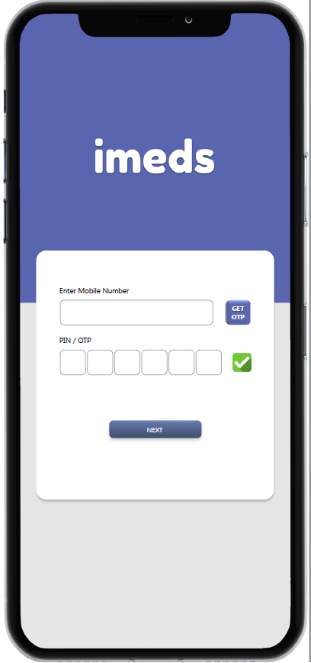

      - Registration Page
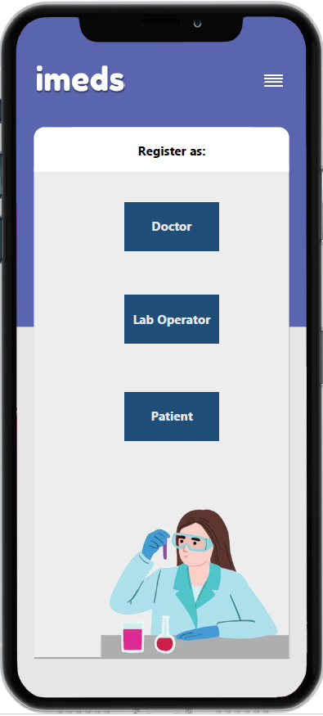

      - Patient Registration Page
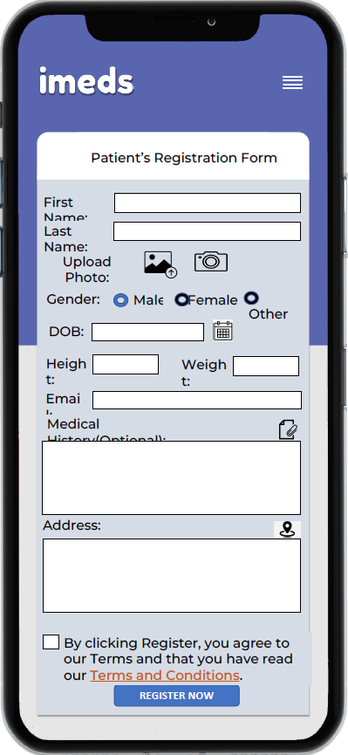

      - Doctor Registration Page
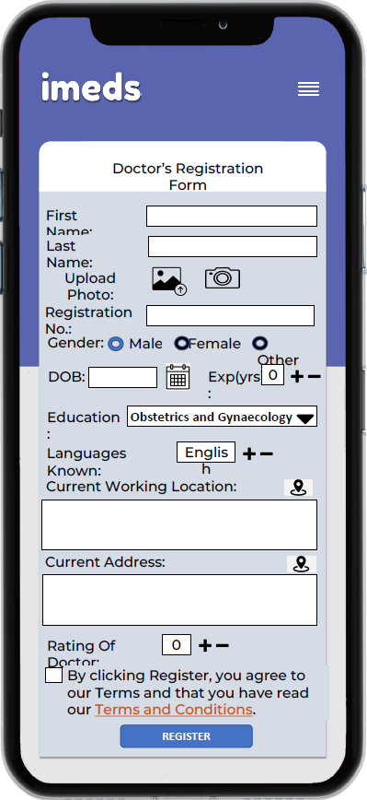

      - Laboratory Registration Page
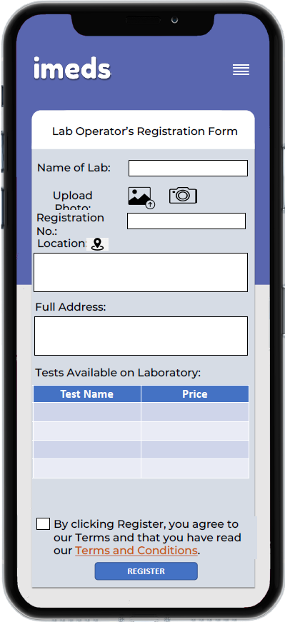

      - Patient Dashboard
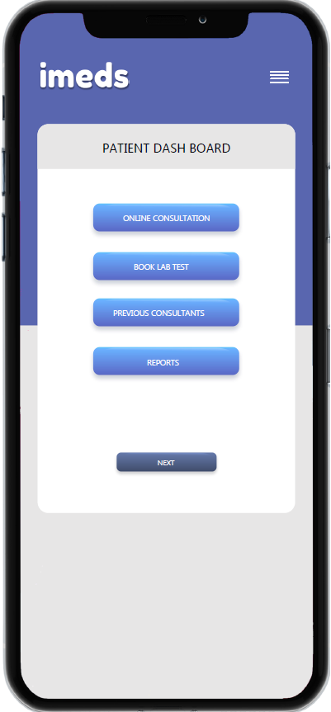

      - Doctor’s Dashboard
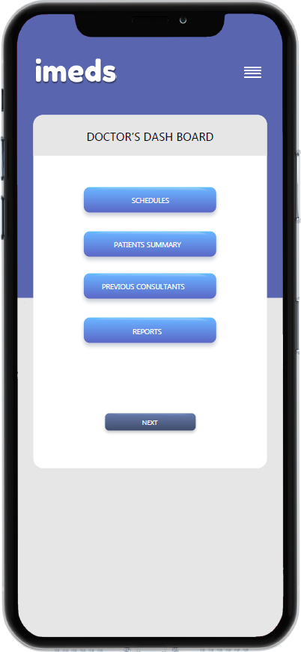

      - Select Doctor for appointment
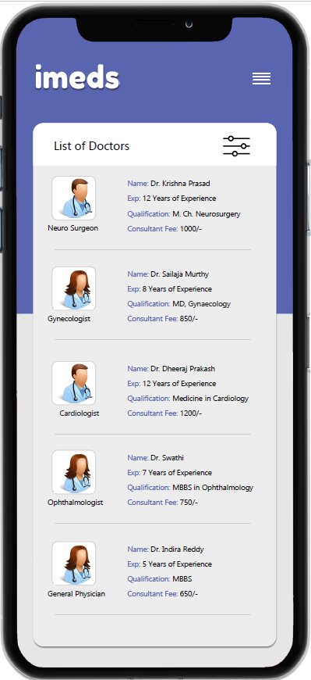

      - Symptom based doctor selection
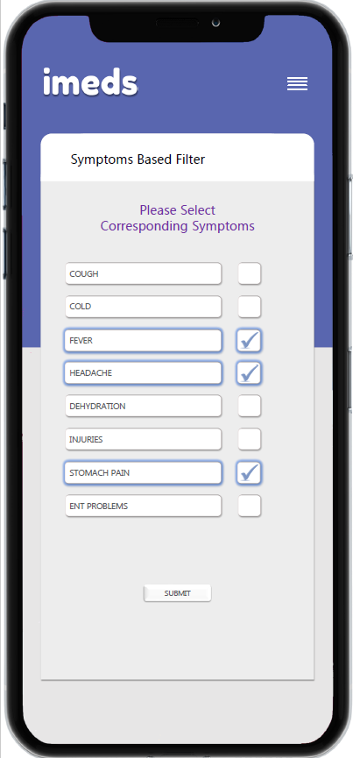

      - Slot and Date selection for appointment
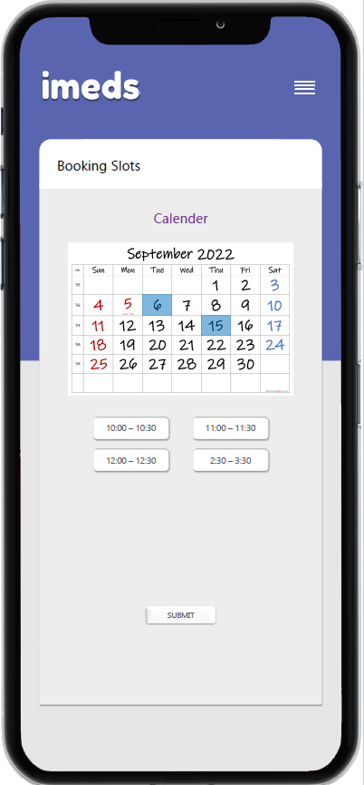

      - Doctor’s appointment calendar
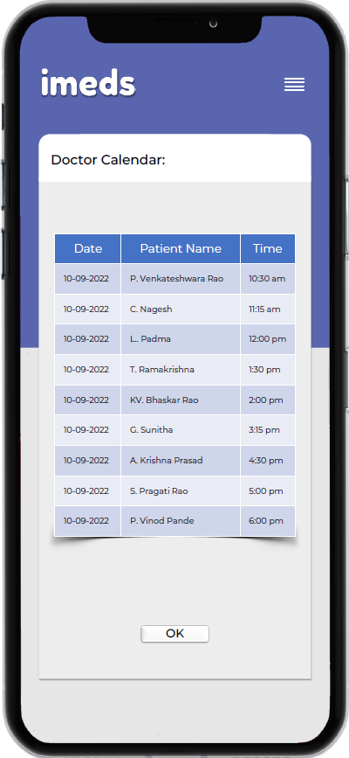

      - Consultation Room – Text Based
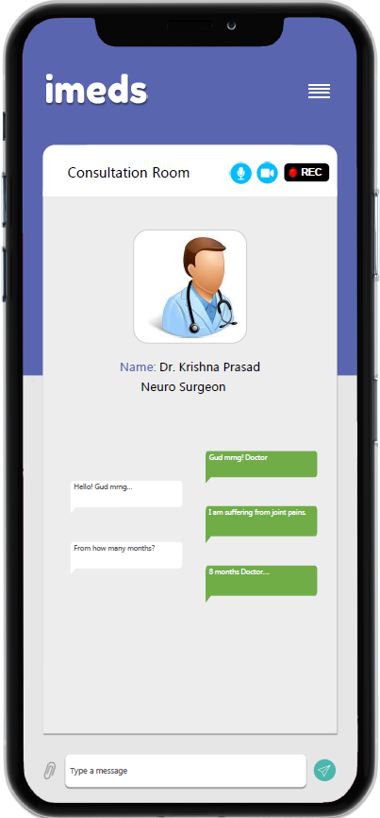

      - Video call based consultation
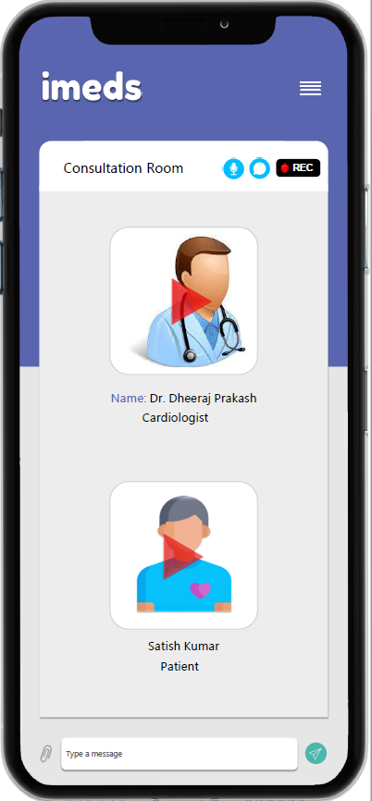

      - Voice call based consultation
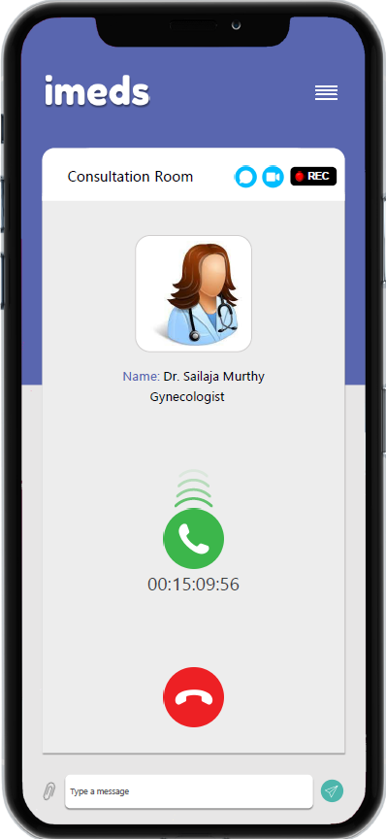

      - e-Prescription
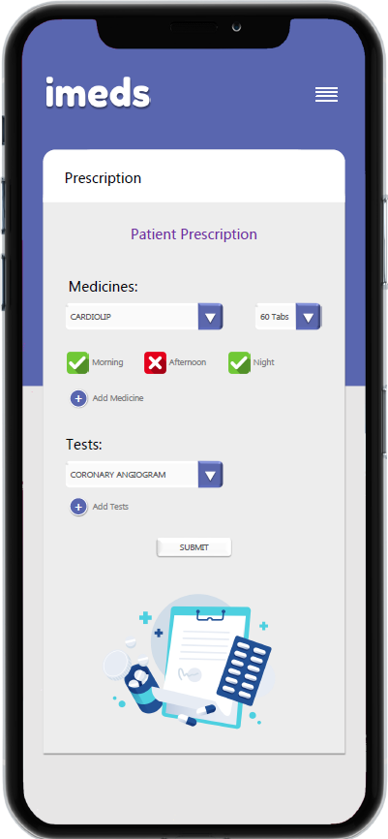

      - Case study by doctor

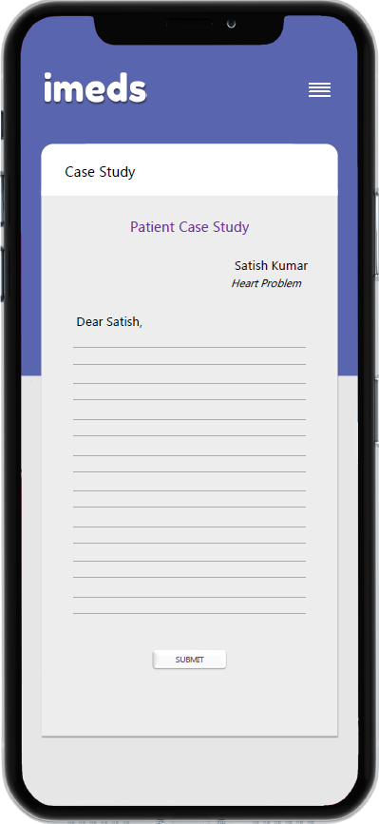

      - Book Lab Tests
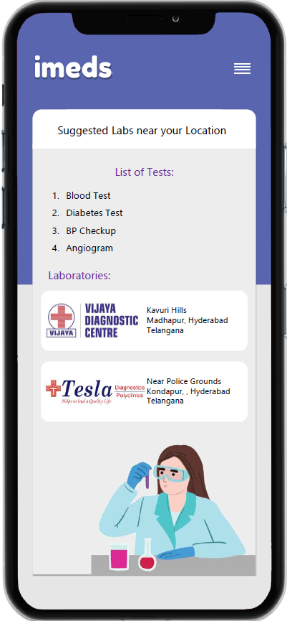
    - Hardware Interfaces
The web application will be ported on a cloud platform with required resources.

    - Software Interfaces
The web application shall provide APIs to be consumed by Mobile application. Same data shall be displayed in both Web application and Mobile application. Users shall be able to access the healthcare features from mobile or tablet or laptop.
    - Communications Interfaces
NA

    - System Interfaces
      - Mobile application to APIs
The mobile application shall consume REST APIs provided by the web application for accessing any feature.
      - Database interface
All transactional data, user data, reports and logs shall be stored in the database. The web application shall connect to the database for accessing these records on request.

    - Software Architecture
The web application shall be developed in MVC architecture.
The mobile application shall be developed in hybrid technologies. A single code base shall be used to generate build for installation on Android and IOS platforms. Both web application front end and mobile application shall access the same APIs for transactions and reports.
  - System Features
This section describes the functional requirements of the system, which are expressed in the natural language style. This section is typically organized by features. All these features shall be available in both web application and mobile application. The following are the main features of the system.
- Authentication & Security
- User registration
- Online consultation
- Reminders
- Laboratory Management
- Reports
- Logging
- Family Doctor
- Pharmacy management
- Hospital management

    - Authentication & Security
      - Introduction/Purpose of feature
Each user is identified by a unique mobile number. Users shall be authenticated before accessing any feature in mobile app or in web application. The authentication shall be based on a registered mobile number and OTP. After successful authentication, the app shall display a home screen or dashboard. The app shall identify the type of user (doctor, patient or lab operator) based on login mobile number.
      - Stimulus/Response Sequence
Message is reconstructed and stored to database.
      - Associated Functional Requirements
Req.ID | Requirement | Addl. Information | Priority
 | The web application and mobile application shall authenticate users based on registered mobile number | If entered mobile number is already registered, the app shall display dashboard. If entered mobile number is not registered, the app shall display registration page | High
 | The web application shall generate a unique OTP for login | The OTP shall be sent to the registered mobile number.  The web application shall forward OTP to SMS gateway for forwarding to mobile number | High
 | The APIs exposed by the web application shall handle OWASP API Security Top 10 Vulnerabilities 2019 |  | High
 | The application shall identify each user based on registered mobile number | Following types of users shall be supported:  - Doctors  - Patients  - Laboratory admin  - Pharmacy  - Front desk operators  - System users | High
 | The application shall display dashboard based on logged in user type | For Doctors following links shall be provided in Home screen:  - Today’s consultations  - Previous consultations  - Calendar  For patients, following menu shall be available in dashboard (Home screen)  - Online consultation  - Follow-up consultation  - Schedule lab test  - Previous consultations  - Profile management  For Laboratory Admin, following menu shall be provided:  - Today’s appointments  - Previous appointments  - Upload reports | High
 | The APIs shall be use at least TLS v1.2 for securing data transfer between web server and mobile/web application |  | High

    - User Registration
      - Introduction/Purpose of feature
The user registration process involves the addition of different types of users. The users are classified as system admins, doctors, patients, laboratories and pharmacy. Each user will have different fields. One patient may register one or more family members. Each user shall have a relevant dashboard for ease of navigation.
      - Stimulus/Response Sequence
Each use registers using unique mobile number.
System stores all user data and makes it ready for future access.

      - Associated Functional Requirements
Req.ID | Requirement | Addl. Information | Priority
 | The system shall provide a facility for registration of users. | Users are classified into five types:  - Doctor  - Patient  - Laboratory Admin  - Pharmacy  - Front desk operator  - System admin | High
 | The system shall provide all required fields for registration of a doctor | The doctor registration shall include but not limited to the following fields:  - Photo,  - Education,  - Specialty  - Yrs of exp  - Languages known,  - Current working location  - Current location  - Department  - Rating of doctor  - Registration Number  - Authority of registration  - Mobile number  - Consultation fee  - Validity of consultation | High
 | The system shall provide all required fields for registration of a patient | The patient details shall include the following:  - Photo (with capture or assign from gallery)  - Full Name  - Mobile number  - Alternate mobile number  - Gender  - DOB  - Height  - Weight  - Email ID  - Reference  - Medical history (if any). Attachments shall be supported.  - Address (with GPS location) | High
 | The system shall provide addition of multiple profiles for family members | The details shall be stored separately for each profile. | High
 | The system shall provide all required fields for registration of a Laboratory | The Laboratory details shall include the following:  Photo  Name  Address  Registration Number  Tests provided | High
 | The system shall provide a facility to add multiple tests during laboratory registration | Each test shall have two options:  - Test Name  - Test Cost  - Sample collection at home possible  - Typical report generation time  - Required inventory | High
 | The system shall display dashboard for each user upon login | The dashboard of doctor shall include but not limited to:  - Today’s consultations  - Previous consultations  - Reports  - Patients’ summary  The dashboard for patient shall include but not limited to:  - Consult online  - Book a lab test  - Previous consultations  - Reports  The dashboard for laboratory shall include but not limited to:  - Today’s appointments  - Reports  The dashboard for pharmacy shall include but not limited to:  - Orders in queue for review of prescription and approval  - Approved orders in queue for dispatch  - Orders out for delivery  - Orders delivered  - Analysis Reports | High
 | The system shall provide all required fields for registration of a pharmacy | - The fields shall include:  Pharmacy Name  - Registration number  - Contact person  - Phone number  - Email Id  - Address  - Location (Google location) | High
 | The system shall provide a facility to add system users and front desk operators | The system user and front desk operators shall have following fields:  - Name  - Full Name  - Mobile Number  - Role  - Gender  - Photo  - Email ID  - User ID  - Password  - Designation | High

    - Online consultation
      - Introduction/Purpose of feature
This process involves selection of doctors based on specialization or based on symptoms. After selection of doctor, appointments can be scheduled. After consultation, the doctor may prescribe medicines or tests. If tests are prescribed, the system shall automatically redirect to the nearest laboratories for scheduling appointments. After getting reports from the laboratory, follow-up consultation may take place.
      - Stimulus/Response Sequence
User requests for viewing consultation.
System displays options for doctor selection or symptom selection.
System displays available slots for the doctor based on availability.
User selects a slot and consults doctor online.
      - Associated Functional Requirements
Req.ID | Requirement | Addl. Information | Priority
 | The system shall provide a facility to book online consultation | The system shall display registered profiles for consultation. User shall choose a profile (self or other family member) and go ahead with consultation. | High
 | The system shall display all registered doctors to the user for selection | Filtering shall be provided based on following conditions:  - Languages known  - Yrs of experience  - Specialization  - Consultation fee  - Location  - Rating of doctor | High
 | The system shall display symptoms category wise | The list shall be categorized. The system shall accept multiple symptoms for selection | Medium
 | The system shall recommend, and display doctors based on selected symptoms. | The list shall implement accurate & reliable algorithm for selection of specialization based on selected one or more symptoms | High
 | The system shall provide a facility for spot consultation | Sometimes patients may need immediate consultation. In this scenario, the system shall the availability of doctors and provide the user with list of available doctor. The list shall be populated based on current location of the patient | Medium
 | The system shall display doctor details for quick reference and review by patients | The details shall include:  - Name  - Photo  - Education  - Specialty  - Yrs of exp  - Languages known  - Consultation fee  - Rating of doctor | Medium
 | The system shall display available slots for consultation |  | Medium
 | The system shall provide a facility to doctors for defining consultation times. | The doctor shall be able to block time slots, dates for avoiding consultations. | Medium
 | The system shall keep track of doctors to see if they are online or offline | The system shall monitor app usage and record last access time. Based on app access time, the app shall decide whether the doctor is offline or online | Medium
 | The system shall provide a facility to select a time slot for consultation | The consultation fee may vary based on selected time slot | Medium
 | The system shall provide a facility to make payment for consultation | The system shall be integrated with leading payment gateway for accepting payments. | High
 | The system shall schedule consultation after getting acknowledgement from the payment gateway. | The payment gateway transaction number and status shall be recorded for future reference. | High
 | The system shall add scheduled consultation to the dashboard. | The same shall be displayed to doctor and patient | High
 | The system shall provide a Consult button with a timer displayed on it with remaining time for consultation. | If user taps on Consult button before timer gets finished, the system shall send a notification to doctor that the patient is ready for consultation. | Medium
 | The system shall create a consultation room when doctor taps on Start Consultation button | The consultation room shall provide following information to doctor for prior information:  - Patient Name  - Patient Photo  - Patient Age  - Height  - Weight  - Existing diseases (if any)  - Existing reports (if any)  - Blood Pressure (if measured)  - Glucose levels (if measured)  - Other reports if any | High
 | The system shall provide a facility to join the consultation room started by doctor |  | High
 | The system shall provide a facility for text, audio and video based consultation. | The default consultation shall be video call. | High
 | The system shall implement adaptive video compression based on available bandwidth | If video quality is very poor, the system shall stop video and voice shall continue | High
 | The system shall record complete consultation room | The video/audio/messages shall be stored and shall be available for future review by doctor or patient | Medium
 | The system shall provide a facility to attach a new report in consultation room | The doctor may ask patients to attach any diagnostic test report if available. The system shall provide option to take a photo of the report or to attach report from gallery | Medium
 | The system shall provide a facility to doctor for entering case study and attach to the consultation room | The case study shall be available to both doctor & patient | Medium
 | The system shall provide a facility to end consultation room | The consultation room may be ended by patient or doctor | High
 | The system shall provide a facility to cancel the consultation | The consultation amount shall be returned to the patient based on cancellation policy | High
 | The system shall provide a facility to change the date & time and doctor of consultation | If patient wants to change doctor, difference amount shall be payable | High
 | The system shall provide a facility to add prescription to the consultation | The doctor may prescribe medicines or diagnostic tests. The selection shall be easy and user friendly. The system shall provide quick suggestions based on entered characters for reducing the drafting time.  While entering medicines, the system shall also indicate dosage and special instructions (if any). | High
 | The system shall display prescription to patient. | If diagnostic tests are prescribed, the system shall display Search Lab button. | Medium
 | The system shall provide a facility to share the prescription through whatsapp and other data sharing apps. | The report shall be exported to PDF and shared. | Medium
 | The system shall display list of laboratories for scheduling appointments. | The laboratories shall be selected based on their nearest location. Samples can be collected at home for a few tests. The system shall indicate for some tests samples can be collected at Home | High
 | The system shall assign a unique alpha numeric word for identifying each consultation |  | High
 | The system shall provide a facility to attach reports for prescribed tests manually | The system shall provide a facility to attach from gallery or capture photo | High
 | The system shall provide a facility to send a message to doctor seeking any additional info | The system shall check if consultation period is active. If active, the system shall send the message to doctor otherwise, the system shall indicate the patient to pay for consultation fee.  In general, the consultation period is 6 or 7 days from the date of making payment. This duration shall be defined by doctor | Medium
 | The system shall display received message from patient and he/she shall be able to reply for the same. | The system shall indicate to patient the following states:  - Sent  - Delivered  - Read | Medium
 | The system shall display response received from doctor. | The doctor may prescribe further medicines or diagnostic tests. Similar process shall be followed for updated prescription as well. | Medium
 | The system shall store patient details, prescriptions, messages etc locally on the device also | This content is very crucial and shall be available even if internet is not available. So this information shall be stored locally and on cloud | High

    - Reminders & Notifications
      - Introduction
This process involves configuring and providing reminders & notifications for taking medicines, consultations and appointments. Reminders will help users to take actions at correct time. The notifications shall be displayed in the notification area in both web & mobile applications.

      - Stimulus / Response Sequence
System generates a notification for taking medicine, scheduled consultation, appointments for lab tests, reports availability etc.
User taps on the notification area to check the message.
System displays the message.
      - Associated Functional Requirements
Req.ID | Requirement | Addl. Information | Priority
 | The system shall provide a facility to add reminders for taking medicine | The medicine reminder shall include the following:  - Medicine  - Time of reminder  - Message to display  - Day selection with everyday option  - Reminder audio tone | Medium
 | The system shall generate reminders for medicines | The system shall play audio tone as per configuration | Medium
 | The system shall generate notifications for all events | The events shall include but not limited to the following:  - Consultation started  - Doctor ready  - Patient joined  - Lab reports uploaded  - Message from doctor  - Message from patient  - Message from laboratory  The notifications shall be displayed to all corresponding users.  For eg: Consultation started shall be provided to both doctor and patient  Doctor Ready notification shall be provided patient  Patient joined notification shall be provided to doctor.  Lab reports uploaded notification shall be provided to patient.  Message from laboratory shall be displayed to patient | Medium
 | The system shall display short message and play audio tone for notifications |  | Medium
 | The system shall provide two options to
 | The system shall provide a facility to modify/delete reminders. |  | Medium
    - Laboratory Management
      - Introduction
This process involves accepting lab test appointments and uploading reports. Laboratory Admin may accept the appointment. Laboratory operator collects the samples. After completion of the test, the Laboratory Admin uploads the reports in system.
      - Stimulus / Response Sequence
User schedules lab tests.
System provides notification to laboratory. Lab operator collects samples and Laboratory admin uploads reports.
      - Associated Functional Requirements
Req.ID | Requirement | Addl. Information | Priority
 | The system shall provide a facility to add multiple profiles for lab admins | In laboratory user login, the app shall ask for profile Each lab operator shall have unique pin | High
 | The system shall display scheduled appointments in Laboratory dashboard | The dashboard shall display a list with accept/modify/cancel options. | High
 | The system shall provide a facility to laboratory operator for accept/reject/modify the scheduled appointment |  | High
 | The system shall provide a facility to assign sample collection to some expert | The details of the expert shall be notified to patient along with name, mobile number and time of collection | High
 | The system shall provide a facility to update the status of lab test | The status shall include but not limited to following:  - Sample collection scheduled  - Expert assigned  - Sample collected  - Diagnosis in progress  - Diagnosis completed.  - Report generated | Medium
 | After completion of diagnosis, the system shall provide a facility to update the status of the test |  | Medium
 | The system shall provide a facility to upload completed report | The report shall be attached to the patient’s account. | Medium
 | The system shall generate an SMS to indicate the user that the reports are ready. |  | Medium
 | The system shall send generated report to patient’s registered email ID |  | Medium
 | The system shall provide a facility to send messages to Laboratory seeking information on lab tests |  | Medium
 | The system shall display the message and provide a facility to the lab operator for replying to the message |  | Medium
 | The system shall display the response received from Lab to the patient |  | Medium

    - Reports
      - Introduction
This process involves logging of all transactions and generating reports. System generates reports for each type of user.
      - Stimulus / Response Sequence
User requests for generation of report
System generates reports and displays to users

      - Associated Functional Requirements
Req.ID | Requirement | Addl. Information | Priority
 | The system shall log all previous consultations, previous lab tests, prescriptions, reports and payment history etc. | All this information shall be stored in a database and this information shall be transferred to users based on request. | High
 | The system shall filter patient data based on different selections. | The filter selection for patient reports shall include but not limited to following:  - Doctor  - Dates  - Profile Id | Medium
 | The system shall filter doctor data based on different selections. | The filter selection for doctor reports shall include but not limited to following:  - Patient Id  - Dates  The report shall display total number of consultations for selected period and total payments in the reports | Medium
 | The system shall filter laboratory data based on different selections. | The filter selection for laboratory reports shall include but not limited to following:  - Patient Id  - Doctor Id  - Dates  - Test ID  The report shall display total number of tests conducted for selected period and total payments in the reports | Medium
 | The system shall provide a facility to get the details of selected report from server |  | Medium
 | The system shall provide a facility to generate different logs generated in the system. | The logs shall be categorized into following types:  - Application logs  - Debug logs | Medium

    - Logging
      - Introduction
This process involves logging of all transactions being performed in the system. The logs shall include system generated logs, user logs and debug logs. The logs shall be stored with a timestamp and user Id.
      - Stimulus / Response Sequence
The system logs all transactions and generates reports on request.
      - Associated Functional Requirements

Req.ID | Requirement | Addl. Information | Priority
 | The system shall log all application related events in database | Each log record shall be stored with timestamp | Low
 | The system shall log all transactions in database for future reference | The transactions shall be logged with respect to user ID. | High
 | The system shall log all debug logs for troubleshooting | The logs shall be stored with respect to timestamp | Low

    - Family Doctor
      - Introduction
A family doctor is one who takes care of the whole family. Many doctors train in a specialty area of medicine. However, family doctors are trained in all areas of medicine. Family doctor care for individuals physical, mental, and emotional health. Family doctors get to know their patients. They build a caring relationship with the patient and his/her family. They listen and document patient’s health history. This helps them better understand how to help make good decisions about health.

Family doctors are responsible for diagnosing and treating acute and chronic illnesses. They also provide routine health screenings and counseling on lifestyle changes. This helps prevent health issues before they develop. If you require care from a specialist, your family doctor will refer you to a specialist. He or she will help coordinate all aspects of your care.
This process involves selecting a doctor as a family doctor. All details of the patient shall be made available to the family doctor.

      - Stimulus / Response Sequence
The user selects a doctor as a family doctor.
System sends a request to the doctor.
Doctor approves/rejects the request.
      - Associated Functional Requirements
Req.ID | Requirement | Addl. Information | Priority
 | The system shall provide a facility to select a doctor as family doctor. | The list of doctors shall be displayed with all details like education, current hospital, location etc. | High
 | The system shall send a request to the doctor for approval | The doctor may approve or reject the request. | High
 | The system shall provide complete patient heath history to family doctor upon approval | The health history shall include the following:  - All previous health reports  - All previous consultations (with any doctor)  - Previous medications | High
 | The system shall provide a facility to configure reminders for appointment with family doctor periodically | The periodicity shall be selectable as follows:  - Quarterly  - Half-yearly  - Annually  - Selected date every month | Medium
 | The system shall generate an appointment based on selected schedule | The system shall generate scheduled appointment notification and display in dashboard. The same notification shall be sent through SMS, email and Whatsapp | Medium
 | The system shall display doctor’s calendar with available slots for booking appointment upon clicking on notification | The system shall prefill all required fields and user shall select only time of the day for appointment. | Medium
NOTE: The same workflow shall follow as described in appointment section (Section Online appointment: 3.2.3) after appointment is scheduled.

    - Pharmacy Management
      - Introduction
Pharmacy management includes ordering system, inventory management and reporting. The users can order medicines from web-based ordering system or from mobile application or over the counters. After consultation, the doctor may prescribe some medicine. The system shall direct the users to order medicine online from the same app. The pharmacist will review the prescription and approve the order along with the expected date of delivery. The delivery agent will collect the order and deliver to the user.
      - Stimulus / Response Sequence
The user selects ePharmacy module from Dashboard or Buy option from the ePrescription page.
The system navigates to ePharmacy module and displays the selected medicine with qty and price.
User places the order by choosing the payment option(online or COD (cash on delivery))
The pharmacist reviews the order and approves the order and assigns it to a delivery agent.
The delivery agent will collect the order and deliver it to user.
      - Associated Functional Requirements
Req.ID | Requirement | Addl. Information | Priority
 | The system shall display a dashboard with list of orders after login | The list shall include the following:  - Orders placed  - Orders approved  - Order rejected  - Orders in transit  - Orders delivered  The list shall be updated periodically. | High
 | The system shall display selected order details | Each order shall include but not limited to:  Order Date  Ref doctor  Prescription ID  Customer Ph Number  Customer email ID  Medicine 1 – QTY  Medicine 2 – QTY  .  .  .  Medicine n - QTY | High
 | The system shall provide a facility to order medicines over the counter | The order shall include all the above. | High
 | The system shall provide a facility to indicate the available stock for each medicine | The system shall provide alerts if any medicine is out of stock or required quantity is not available | High
 | The system shall generate an sales billing report for every transaction | The bill shall include patient name, age, bill no (autogenerated), date, consultant doctor, medicine details which includes name of the medicine, quantity, HSN code, Expiry date, price, subtotal, grand total and applicable tax (GST – CGST/IST) | High
 | The system shall generate a print of the invoice for sales bill |  | High
 | The system shall support multiple stores under one pharmacy registration. | Each store shall be identified by location, name, consultant, phone no | Medium
 | The system shall provide a facility to add received stock to store. | While adding stock, the system shall provide a facility to segregate the medicines based on bin no. | Medium
 | The system shall deduct stock from available stock after every sale invoice. |  | High
 | The system shall indicate out of stock items based on configured threshold | The configuration of out-of-stock notification shall be done based on medicine. | Medium
 | The system shall provide a facility to import medicine details from an excel sheet in predefined format | The excel file template shall be defined during design | Medium
 | The system shall provide a facility to add medicine to item history. | Each medicine shall have following details:  - Name  - Image  - Composition  - Category  - Manufacturer  - Storage temperature  - Alternative brands  - Uses  - Additional information  - Bin no  - Price per unit | Medium
 | The system shall display details of medicine in online ordering screen | The information recorded shall be displayed to users to give them idea of what the medicine is and dosage and side effects | Medium
 | The system shall generate various reports related to pharmacy management | The reports shall include:  - Billing per day  - Billing per selected period  - Billing as per selected medicine  - Consolidated billing  - User access report | Medium
 | The store operator shall be allowed to apply discounts up to max configuration while billing | The max discount shall be defined by the system user. The same discount shall be applicable for all medicines under the category | Medium
 | The system shall provide a notification for near expiry medicine which are available in store for disposal or returning to supplier | The system shall display these notifications on dashboard and email. | High
 | The system shall indicate when the stock reaches a minimum level and provide a facility to re-order the same. |  | High
 | The system shall provide a facility to send notification to remind the patient for reordering the medicine before the prescription runs out. | This will enhance the patient relationship with pharmacy | Medium

    - Hospital Management
      - Introduction
Hospital management module provides all required features of the front desk operators in clinic or hospital. A hospital may have a couple of doctors, laboratory, and pharmacy. The hospital management module includes appointment scheduling, calendar management, billing, invoicing, ordering, inventory, prescription management, master data management etc. All front desk operations shall be handled in Hospital management module.
      - Stimulus / Response Sequence
Front desk operator/ system admin logs into the system.
The system displays various options to the user.
User accesses a feature to continue.
System guides the user to complete the transaction.
      - Associated Functional Requirements
Req.ID | Requirement | Addl. Information | Priority
 | The system shall provide a facility to add a patient in the system | The system shall take all details as per 3.2.2.3.3 | High
 | The system shall provide a facility to add a doctor | The system shall take all details as per 3.2.2.3.2 | High
 | The system shall provide a facility to add a laboratory | The system shall take all details as per 3.2.2.3.5 | High
 | The system shall provide a facility to add a pharmacy | The system shall take all details as per 3.2.2.3.8 | High
 | The system shall provide a facility to add multiple tests under laboratory | The system shall take all details as per 3.2.2.3.6 | High
 | The system shall provide a facility to add treatment details | Following details shall be included but not limited to:  - Name  - Code  - Category  - Price | High
 | The system shall have all features of laboratory management | As per section 3.2.5 | High
 | The system shall provide all features of pharmacy management | As per section 3.2.9 | High
 | The system shall provide a facility to add medical package | The package may include various tests including appointments | High
 | The system shall provide a facility to add departments | Each department shall include following:  - Department Name  - Department Code | High
 | The system shall display a dashboard to the front desk operator | The dashboard shall include the following:  - Manage Appointments (book/cancel/update)  - Order Medicine  - Order Lab tests  - Appoints for Today  - Reports | High
 | The system shall provide a facility to book appointment | The appointment shall include registration of patients for new patients. The system shall block time slot for the doctor for the scheduled duration. | High
 | The system shall provide a facility to cancel/update appointment |  | High
 | The system shall provide a facility to generate bill for appointment booking | The bill shall include necessary tax details also | High
 | The system shall provide a facility to create a bill for lab tests | The bill shall include necessary tax details also. The system shall deduct stock related to the test automatically from inventory when a bill is generated | High
 | The system shall provide a facility to create a bill for pharmacy | The bill shall include necessary tax details also. The system shall deduct stock automatically when a bill is generated | High
 | The system shall provide a facility to order medicine in case of low stock | The system shall proactively generate alerts in case of low/no stock | High
 | The system shall generate a report on all consultations for the selected period | The reports shall have filters like doctor selection, department selection, treatment selection, daywise and week wise etc | Medium
 | The system shall generate a report on all lab tests done for the selected period | The report shall have filters like test, daywise, week wise, month wise, equipment wise, referral doctor wise etc | Medium
 | The system shall generate a report on all medicine orders | The report shall have various filters like: daywise, week wise, month wise, group wise, supplier wise etc | Medium
 | The system shall provide a facility to manage roles of each front desk operator | The system shall have page level/role level authorization. | High
 | The system shall provide a facility to manage discounts for tests, appointments, medicine orders | The discount management shall be done by system users only | Medium

  - Online User Documentation and Help System Requirements
Context help should be provided, User manual and Operational Manual User manual should contain how to use the application with required navigation and concept behind each feature. Operation manual includes trouble shooting, any system related activities and Solutions to dynamic errors

